https://www.pes.edu/wp-content/uploads/2019/09/pes_logo.png

**END SEMESTER ASSESSMENT (ESA) B.TECH. (CSE)**

**IV SEMESTER**

**UE18CS256 – MICROPROCESSOR AND COMPUTER ARCHITECTURE LABORATORY**

**PROJECT REPORT**

**ON**

Fire Alarm (Alert) and Extinguishing System

SUBMITTED BY

**NAME SRN**

1. **Serena A. Gomez PES2UG19CS372**
2. **Roshni Govind PES2UG19CS339**
3. **Sahil Elton Lobo PES2UG19CS348**
4. **Sanjana S Murthy PES2UG19CS364**

**JANUARY – MAY 2021**

**DEPARTMENT OF COMPUTER SCIENCE & ENGINEERING**

**ELECTRONIC CITY CAMPUS,**

**BENGALURU – 560100, KARNATAKA, INDIA**

|  |  |  |
| --- | --- | --- |
| TABLE OF CONTENTS | | |
| Sl.No | TOPIC | PAGE No |
|  | ABSTRACT OF THE PROJECT | 3 |
|  | CIRCUIT DIAGRAM | 4 |
|  | ARDUINO CODE | 5 |
|  | SCREEN SHOTS OF THE OUTPUT | 6 |
|  | REFERENCES | 7 |

**ABSTRACT OF THE PROJECT:**

AIM:

Designing a system to detect fire, as it breaks out and to alert people in the vicinity as well as concerned authorities far away, while deploying immediate measures to reduce the effect of the fire.

ABSTRACT:

* This project encapsulates the aspects of hardware as well as software into a single project. Sensors and electrical circuitry have been incorporated with software i.e., code with Arduino used as a segue.
* The two libraries used to code are servo.h and softwareserial.h
* The MQ-2 smoke sensor is our primary sensor that has been connected to a certain port which has been declared as an input port thus providing the smoke level in the room. The other sensors have been connected to output ports.
* The GSM module is connected to pins 9 and 10 which are PWM(pulse width modulation) enabled pins used for serial communication.
* When the gas levels are in a safe range the green LED is on and no buzzer rings. As the gas levels rises steadily the yellow LED is turned on and the buzzer rings at a low frequency. When the gas levels are in a dangerous range the red LED is turned on, the alarm blares at a higher frequency and an SMS alert is relayed from the GSM module to the registered mobile number.
* In addition to this, the servo motor connected to the tap controlling the sprinkler system is turned 180 degree to release water to put out the fire.
* When the gas level reduces to a safe level again indicating that the fire is out, the servo motor resets to -180 degree to turn the tap off.

COMPONENTS REQUIRED:

* Arduino UNO
* GSM 800a module
* MQ-2 gas sensor
* Micro Servo
* DC power source
* Piezo Buzzer
* 3 coloured LEDs
* 12v adapter
* Jumper cables
* 220ohm resistors

**CIRCUIT DIAGRAM:**

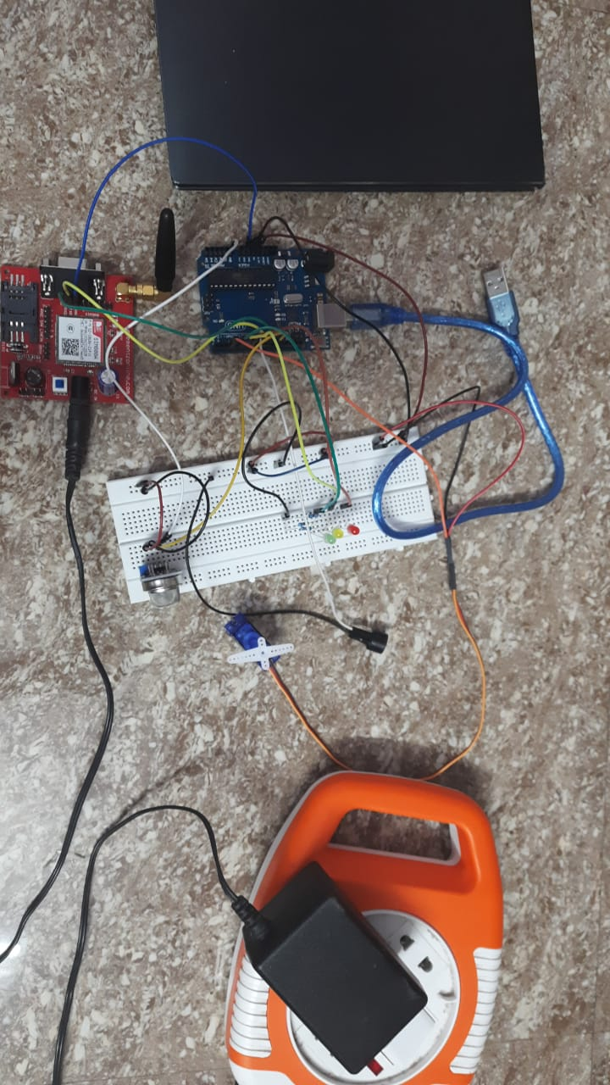

**ARDUINO CODE:**

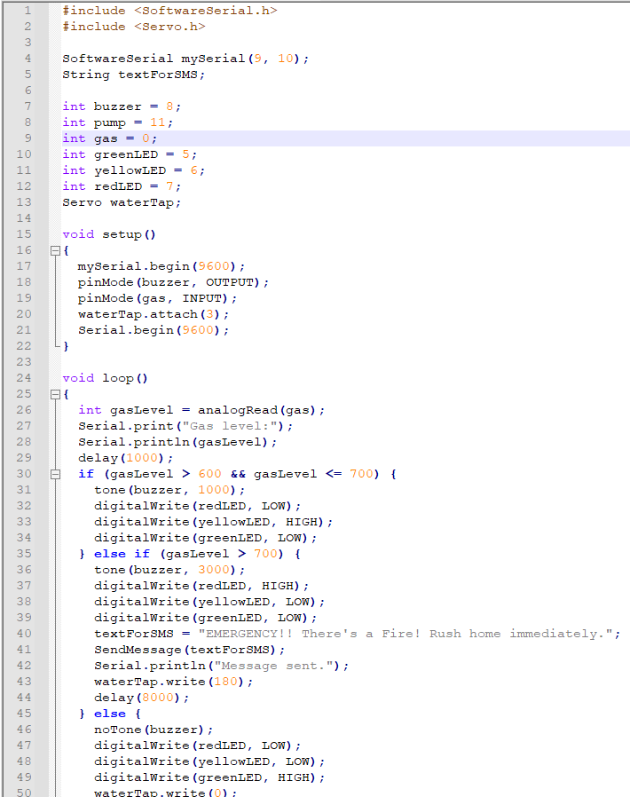

**SCREEN SHOTS OF THE OUTPUT:**

**WORKING:**

[**https://drive.google.com/file/d/1LTRUNaN-3CiaREUxMl0obaOypNhXvfX7/view**](https://drive.google.com/file/d/1LTRUNaN-3CiaREUxMl0obaOypNhXvfX7/view)

**DEMO:**

[**https://drive.google.com/file/d/1LV8QY91e2WTkWZibpxIJHrdKJe1R_RQ9**](https://drive.google.com/file/d/1LV8QY91e2WTkWZibpxIJHrdKJe1R_RQ9)

**REFERENCES**

* [**Smoke Detection using MQ-2 Gas Sensor - Arduino Project Hub**](https://create.arduino.cc/projecthub/Aritro/smoke-detection-using-mq-2-gas-sensor-79c54a?ref=search&ref_id=smoke%20sensor&offset=0)
* [**DC piezo buzzer volume control - Arduino Project Hub**](https://create.arduino.cc/projecthub/glennedi/dc-piezo-buzzer-volume-control-4a230b?ref=search&ref_id=piezo%20buzzer&offset=1)
* [**Servo: Arduino Basics - Arduino Project Hub**](https://create.arduino.cc/projecthub/glowascii/servo-arduino-basics-cb9266?ref=search&ref_id=servo&offset=1)
* [**Arduino PWM Tutorial - Arduino Project Hub**](https://create.arduino.cc/projecthub/muhammad-aqib/arduino-pwm-tutorial-ae9d71)
* [**Interface GSM Module to Arduino - Send and Receive SMS (circuitstoday.com)**](https://www.circuitstoday.com/interface-gsm-module-with-arduino)